**Test Report for Random Date Generator**

**Project Name:** Random Date Generator Manual Testing on Web UI Application

**Date:** Feb 17th 2025

**Assessment time:** completed within 1 hr

**Test Summary:**

The purpose of this test is to verify the functionality of the random date generator. The generator should produce random dates within a specified range and ensure that the dates and formats are valid.

**In Scope:** Only the random date generator is in scope for this manual testing.

**Test Cases:**

20 TCs were planned to test

**Edge Browser:** 4 basic TCs were mentioned below in the table

| Test Case ID | Test Case Description | Test Steps | Expected Result | Actual Result | Status: Pass/Fail |
| --- | --- | --- | --- | --- | --- |
| TC001 | Generate a random date within the current year | 1. Set the date range to the current year MM-DD-YYYY  . 2. Generate a random date. | The generated date should be within the current year. | The generated date is within the current year. | Pass |
| TC002 | Generate a random date within a specific range | 1. Set the date range from e.g:02/01/2000 to 12/30/2020.  2. Generate a random date. | The generated date should be within the specified range. | The generated date is within the specified range. | Pass |
| TC003 | Validate the format of the generated date | 1. Generate a random date. 2. Check the format of the date. | The date should be in the format custom format. | The date is in the correct format. | Fail |
| TC004 | Generate multiple random dates and check for duplicates | 1. Generate 365/366 random dates. 2. Check for duplicates. | There should be no duplicate dates. | No duplicates found. | Fail |

**Test Cases:**

**Edge Browser:**

1. Scenario: Random dates is generated for given start and end date range for given count.

PASS

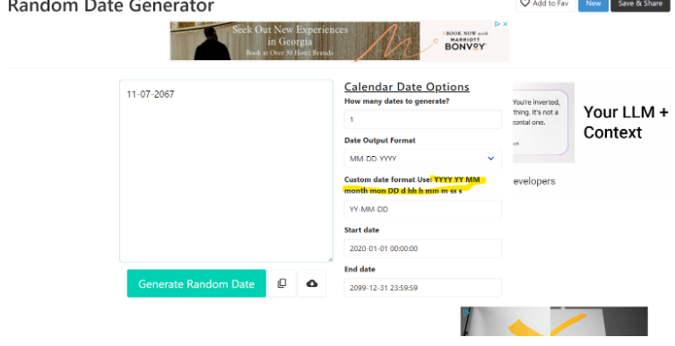

2. Scenario: Random dates is generated for this current year given start and end date range for given count.

PASS

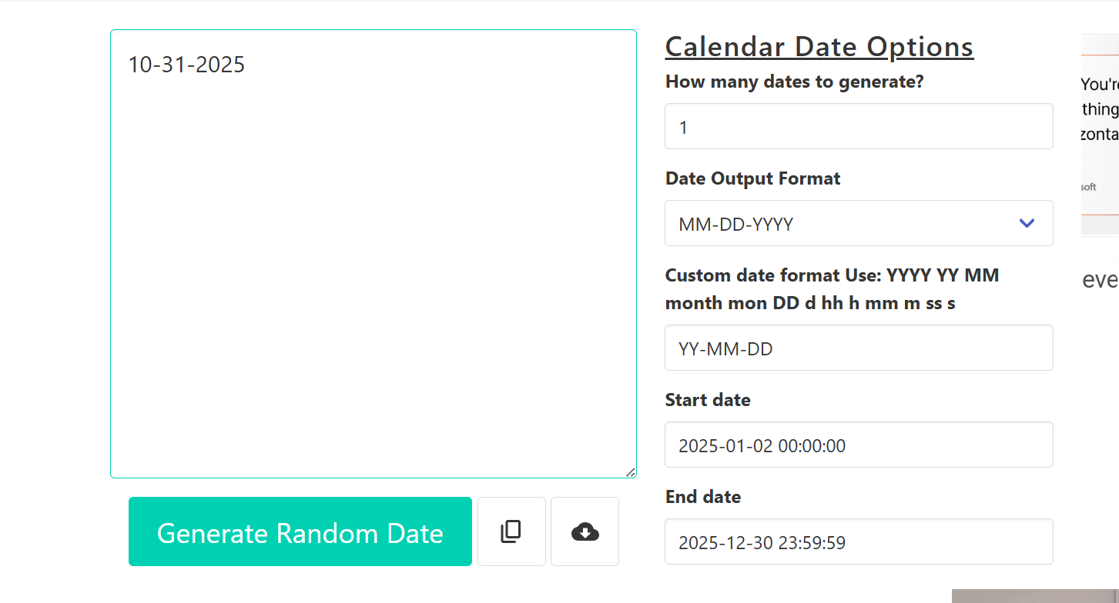

3: Scenario: Random dates is generated for this current year given start and end date range for given count. Validate Duplicate dates in generated output.

Below are list of duplicates in the output

Fail

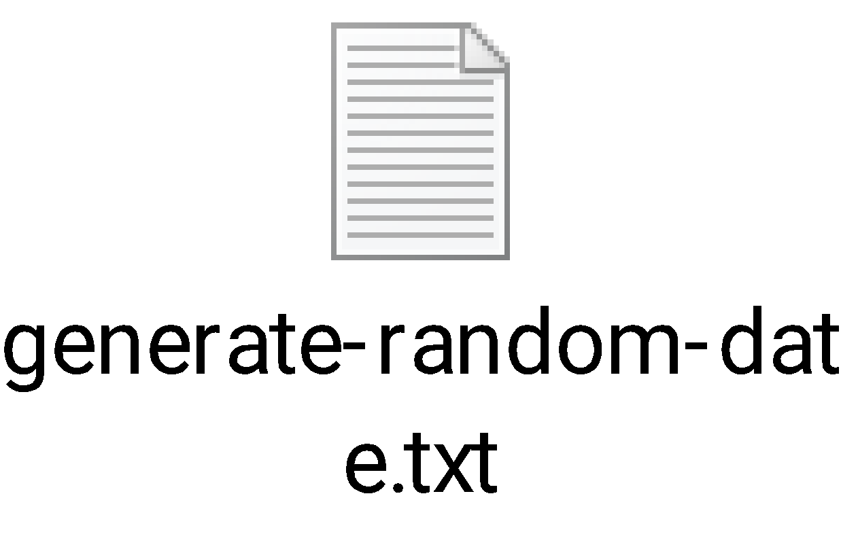

Duplicate dates:

Duplicate Dates: [11-07-2025, 08-01-2025, 10-27-2025, 06-08-2025, 01-31-2025, 11-12-2025, 12-18-2025, 01-16-2025, 03-13-2025, 05-28-2025, 04-08-2025, 02-04-2025, 10-03-2025, 04-13-2025, 12-23-2025, 01-19-2025, 03-14-2025, 08-07-2025, 10-24-2025, 06-01-2025, 03-17-2025, 05-17-2025, 09-06-2025, 11-28-2025, 02-02-2025, 08-11-2025, 01-05-2025, 10-13-2025, 04-18-2025, 07-29-2025, 12-22-2025, 02-13-2025, 01-08-2025, 05-09-2025, 01-02-2025, 09-13-2025, 03-23-2025, 05-06-2025, 11-19-2025, 07-05-2025, 09-02-2025, 06-22-2025, 04-23-2025, 01-10-2025, 07-21-2025, 09-30-2025, 12-04-2025, 08-03-2025]

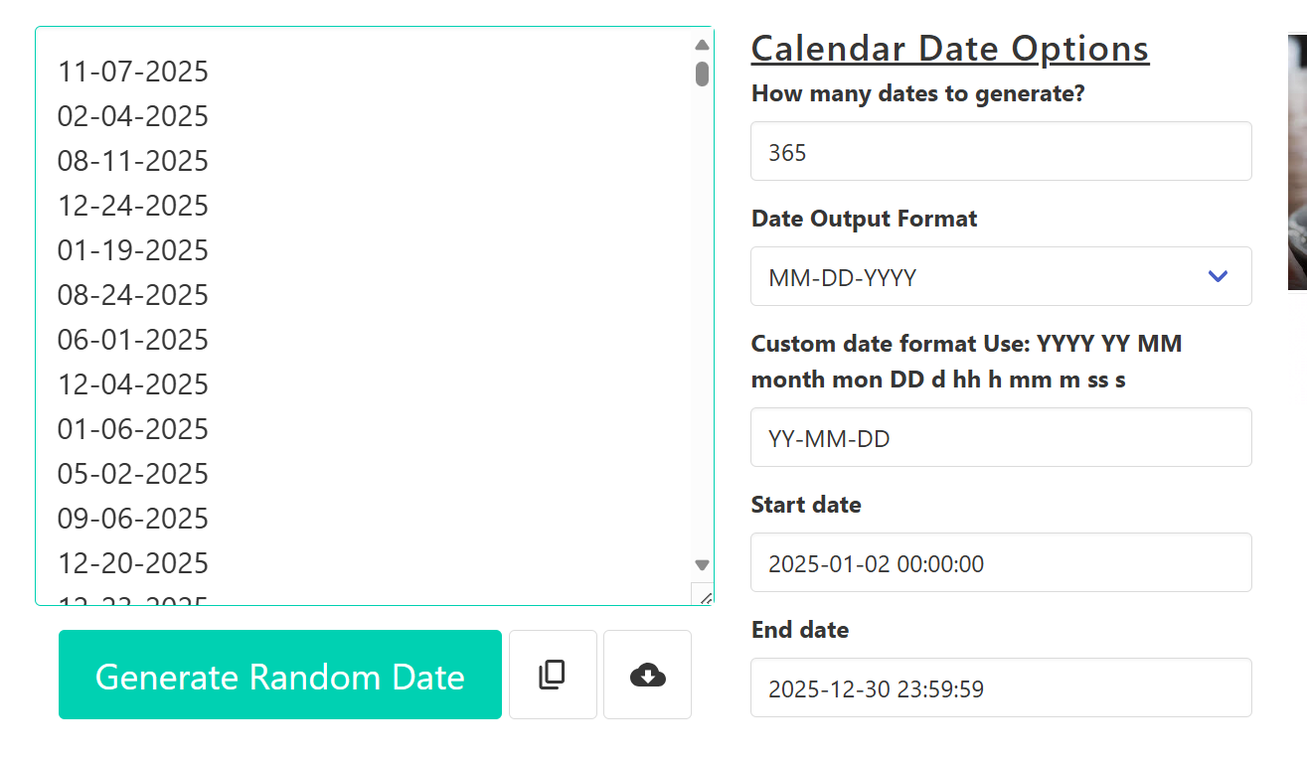

Working as expected format and date range

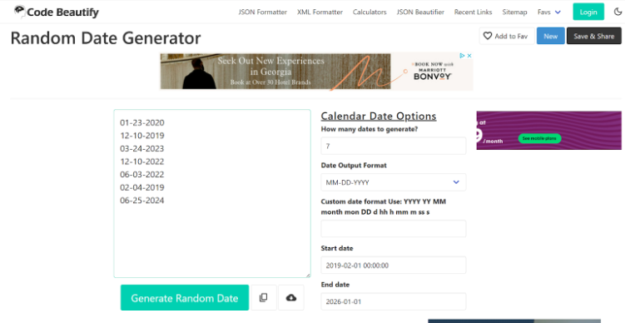

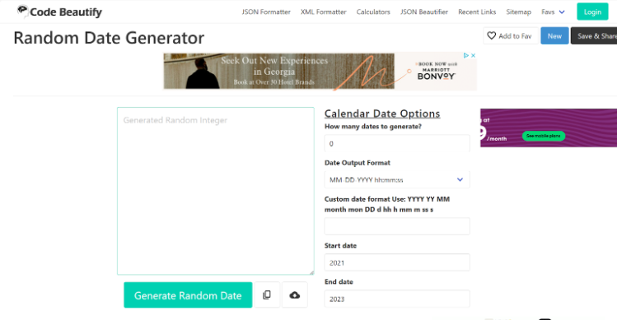

Facing this issue many times -> UI is not loading after some TCs execution:





UI Page is not responding if we provide 99999 value in dates count:

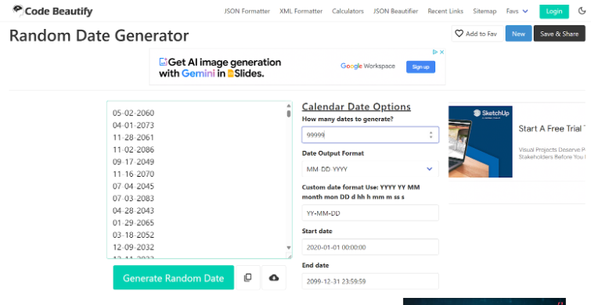

**Bugs were reported during this testing:**

4. Scenario: Validate Date output format (Date timestamp)for given date range

Start date 2021

End date 2019

Output is invalid  
Fail

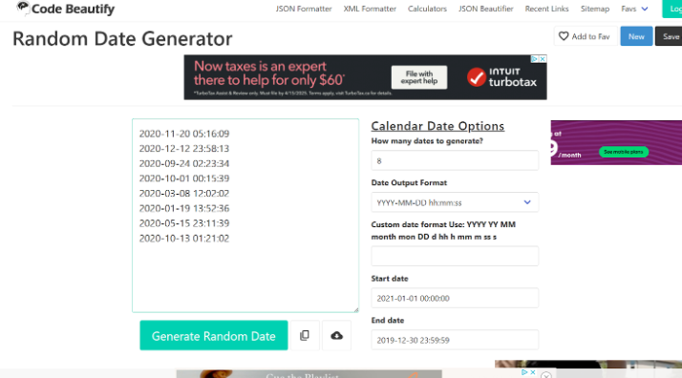

5: Scenario – Generated output is incorrect for given date range

Fail

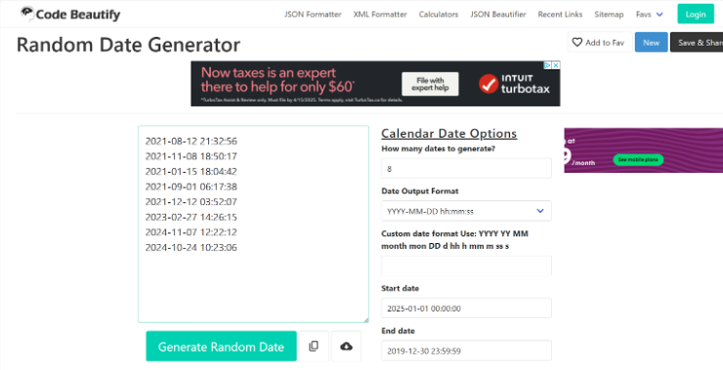

6: Scenario – Validate Generated output for given start date only

Fail

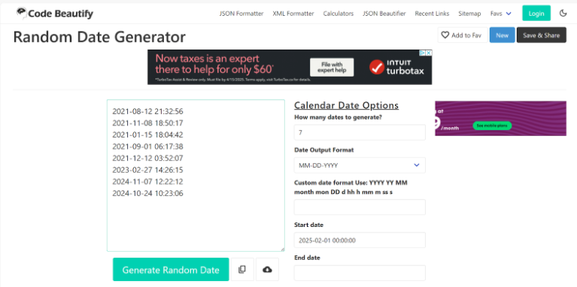

7: Validate the output for Negative value in field How many dates to generate

Fail

Expected: Accept only valid positive integers

Actual: Accept negative value as well and no output generated

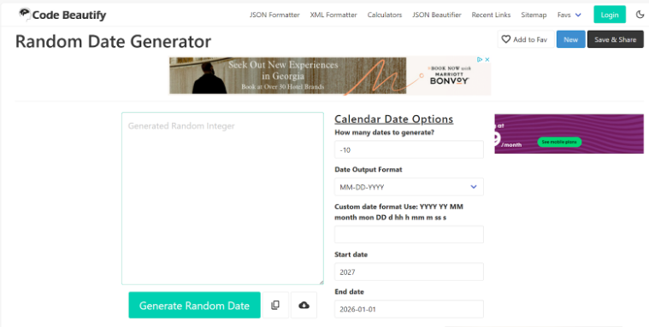

8: Validate output for given end date only

Fail

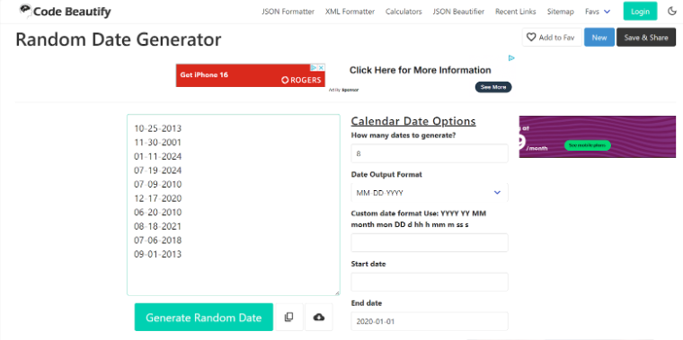

9: Validate output for selected format

Expected : Year Date Month

Actual : year Month Date

Fail

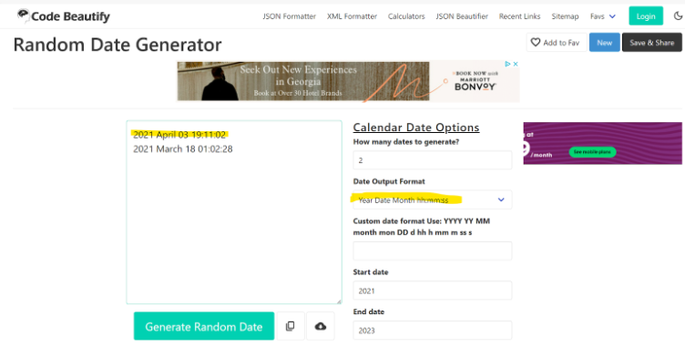

10: Validate output for Custom Date format

Fail

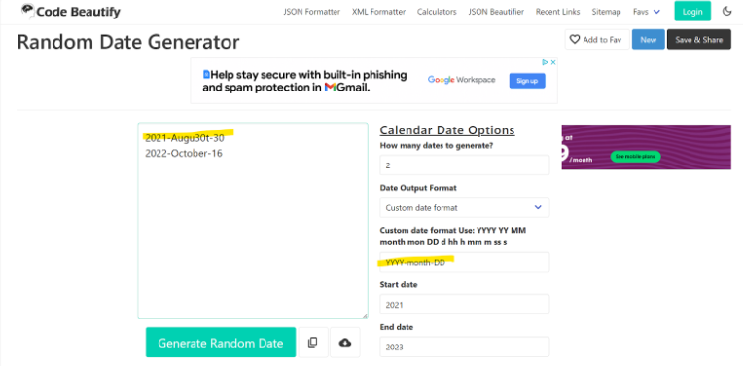

11: Validate output for Custom new format :

fail

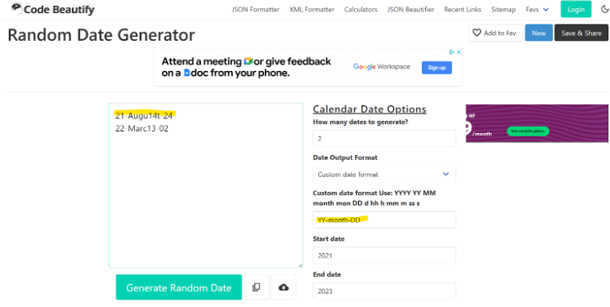

12: Validate output for custom date timestamp - Fail

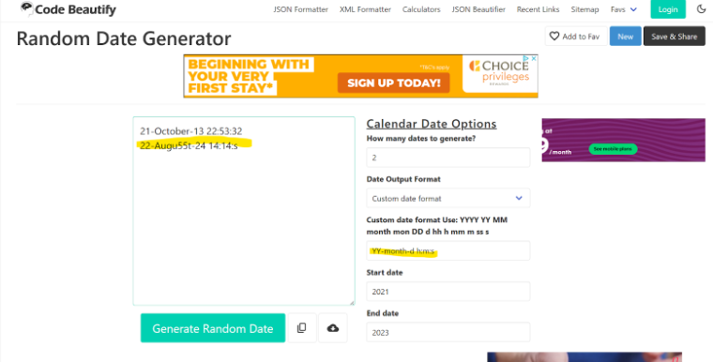

13:

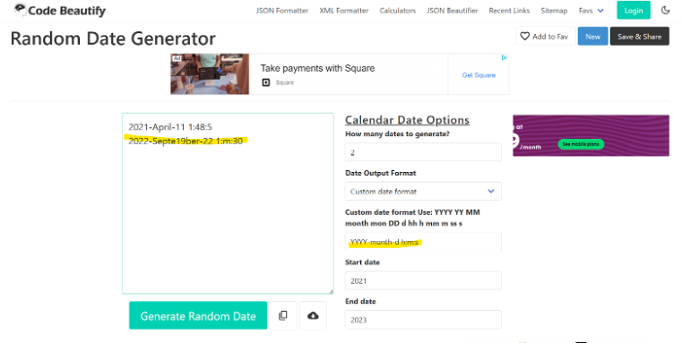

14:

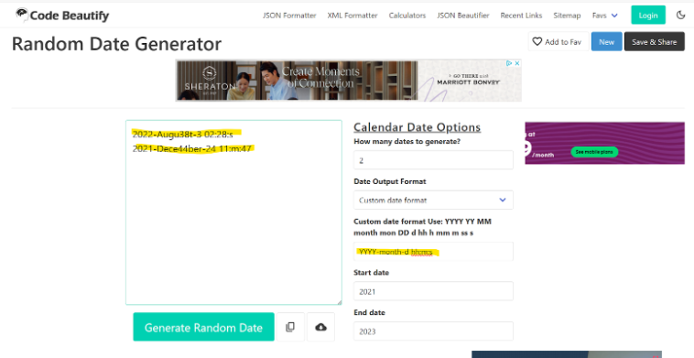

15: Validate output for given start year only

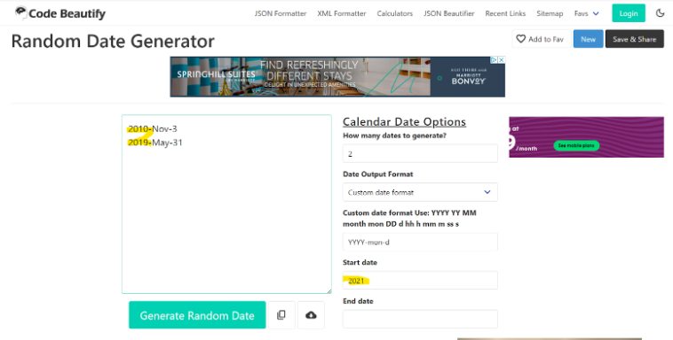

Screen stuck no change in response:

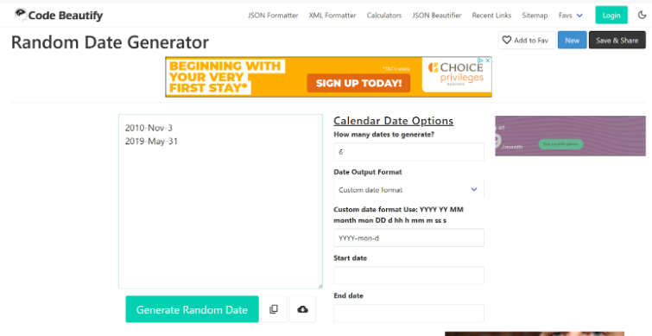

16:

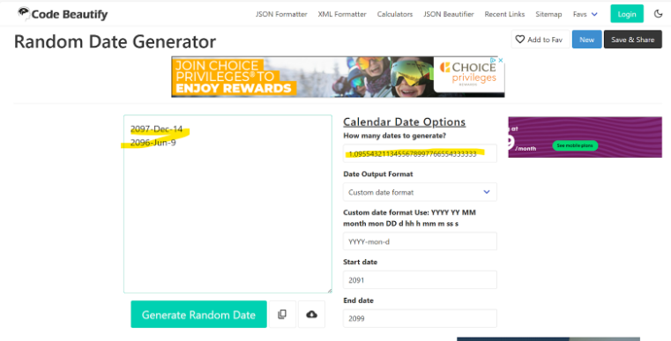

17:

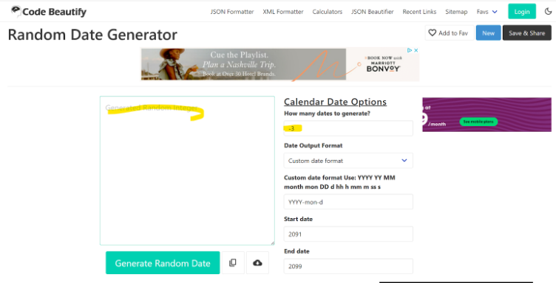

18: Bug : -, +, ., -ve, +ve, 0, e, decimal

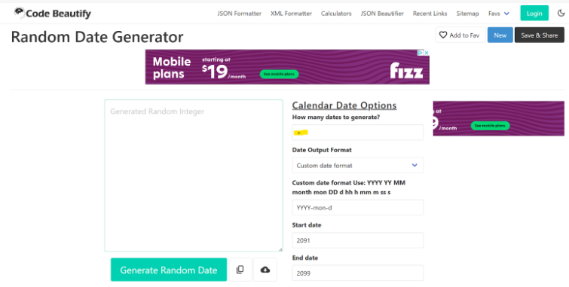

19: Bug

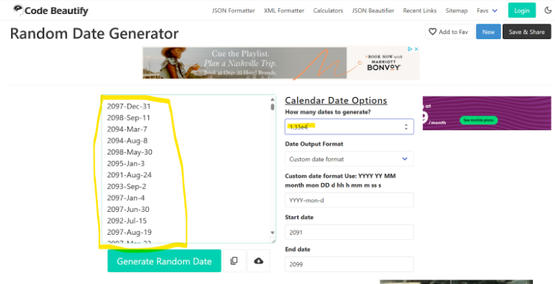

20:

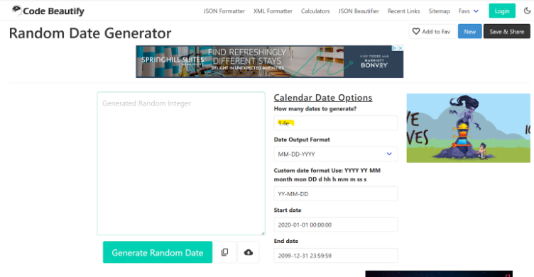

21: Bug:

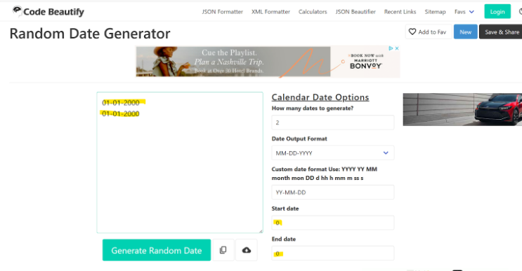

Test Results:

Total Executed: 20

Passed Count: 3

Failed Count: 17

Bug Report

* Total: 17 bugs were found during testing.
* Description: The output is not as expected for the given input.
* Steps to Reproduce: Different for each bug.
* Severity: High
* Priority: High
* Status: Open
* Environment:
  + System: Windows 11
  + Browser: Edge
* Attachments: Screenshots are attached to the specific bugs mentioned above.